**AYESHA MUKATI 24MBD017 BIG DATA ASSIGNMENT**

**Aim: Creating a Billing Software using Python and MongoDB.**

**Output:**

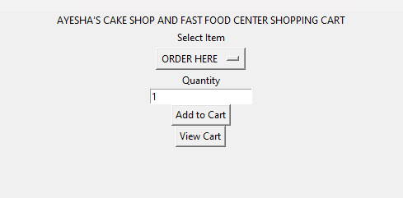

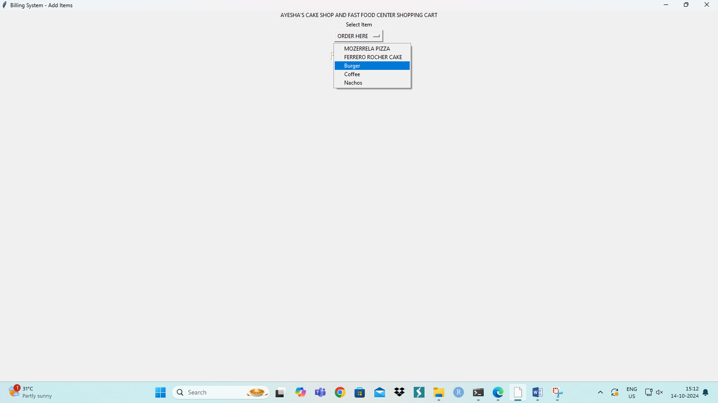

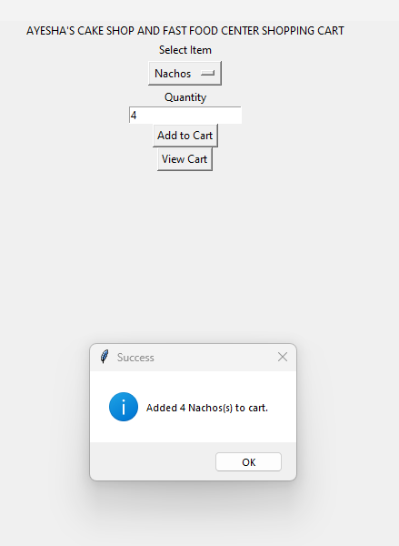

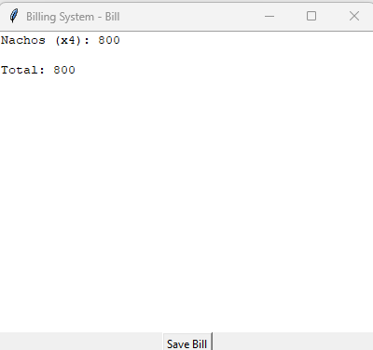

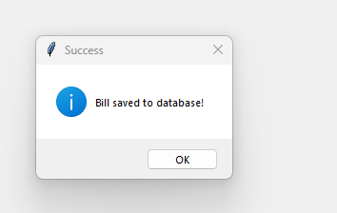

**Database Output Screenshots:**

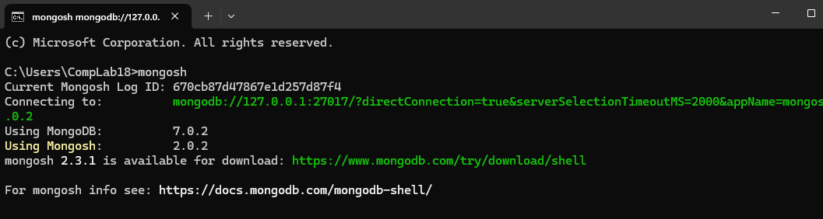

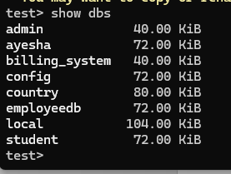

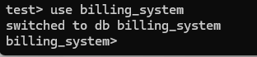



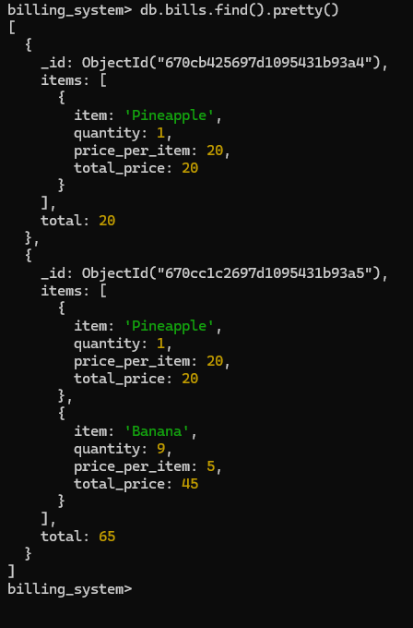

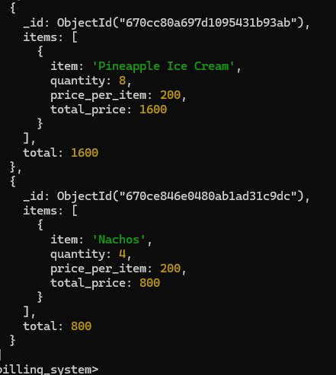

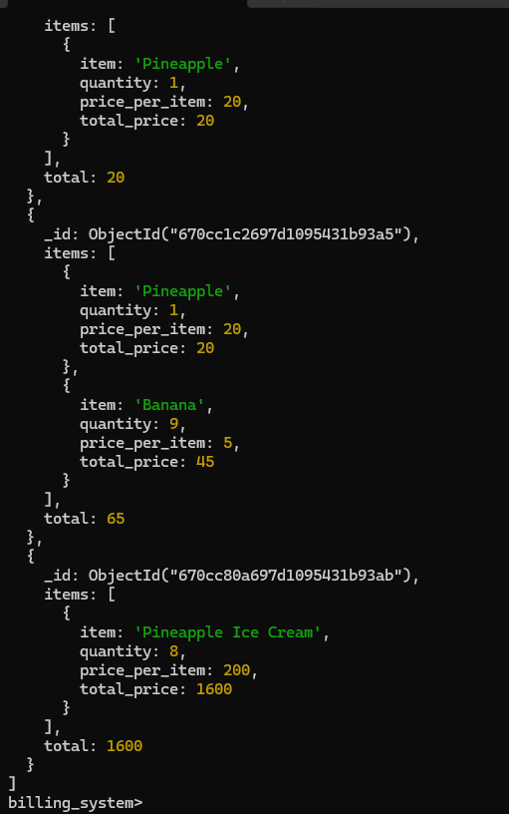

**CODE:**

pip install pymongo tkinter

import tkinter as tk

from tkinter import messagebox

from pymongo import MongoClient

from bson.objectid import ObjectId

# MongoDB setup

client = MongoClient('mongodb://localhost:27017/')

db = client['billing_system']

items_collection = db['items']

bills_collection = db['bills']

# Item list with prices

items = {

"Apple Milkshake": 100,

"Banana Pudding": 50,

"Orange Juice": 70,

"Mango Creame": 150,

"Pineapple Ice Cream": 200

}

# First form: Add items to cart

class AddItemsForm:

def __init__(self, root):

self.root = root

self.cart = []

self.total = 0

self.root.title("Billing System - Add Items")

self.label = tk.Label(root, text="AYESHA'S FRUIT JUICE CENTER SHOPPING CART")

self.label.pack()

self.label = tk.Label(root, text="Select Item")

self.label.pack()

self.item_var = tk.StringVar(root)

self.item_var.set("Apple") # default value

self.dropdown = tk.OptionMenu(root, self.item_var, *items.keys())

self.dropdown.pack()

self.quantity_label = tk.Label(root, text="Quantity")

self.quantity_label.pack()

self.quantity_var = tk.IntVar(value=1)

self.quantity_entry = tk.Entry(root, textvariable=self.quantity_var)

self.quantity_entry.pack()

self.add_button = tk.Button(root, text="Add to Cart", command=self.add_to_cart)

self.add_button.pack()

self.view_cart_button = tk.Button(root, text="View Cart", command=self.view_cart)

self.view_cart_button.pack()

def add_to_cart(self):

item_name = self.item_var.get()

quantity = self.quantity_var.get()

price = items[item_name]

total_item_price = price * quantity

self.cart.append({

"item": item_name,

"quantity": quantity,

"price_per_item": price,

"total_price": total_item_price

})

self.total += total_item_price

messagebox.showinfo("Success", f"Added {quantity} {item_name}(s) to cart.")

def view_cart(self):

BillForm(self.root, self.cart, self.total)

# Second form: Display bill and save to MongoDB

class BillForm:

def __init__(self, root, cart, total):

self.root = root

self.cart = cart

self.total = total

self.bill_window = tk.Toplevel(self.root)

self.bill_window.title("Billing System - Bill")

self.bill_text = tk.Text(self.bill_window, width=50, height=20)

self.bill_text.pack()

self.display_bill()

self.save_button = tk.Button(self.bill_window, text="Save Bill", command=self.save_bill)

self.save_button.pack()

def display_bill(self):

bill_text = ""

for item in self.cart:

bill_text += f"{item['item']} (x{item['quantity']}): {item['total_price']}\n"

bill_text += f"\nTotal: {self.total}"

self.bill_text.insert(tk.END, bill_text)

def save_bill(self):

bill_data = {

"items": self.cart,

"total": self.total

}

bills_collection.insert_one(bill_data)

messagebox.showinfo("Success", "Bill saved to database!")

# Main application

if __name__ == "__main__":

root = tk.Tk()

app = AddItemsForm(root)

root.mainloop()